ASSIGNMENT: C2 Bonus

FILE: C2_ACT_katherto.pdf

DATE: 27 January 2016

BY: Kathryn Atherton

katherto

Joshua Hahn

Hahn28

Hannah Mackin Schenck

hmackins

SECTION: 03, 1:30-3:30

TEAM: 45

ELECTRONIC SIGNATURE:

Kathryn Atherton

Joshua Hahn

Hannah Mackin Schenck

The electronic signatures above indicate that the document submitted for evaluation is the combined effort of all team members and that each member of the team was an equal participant in its creation. In addition, each member of the team has a general understanding of all aspects of the document.

**TASK 1**

PART A:

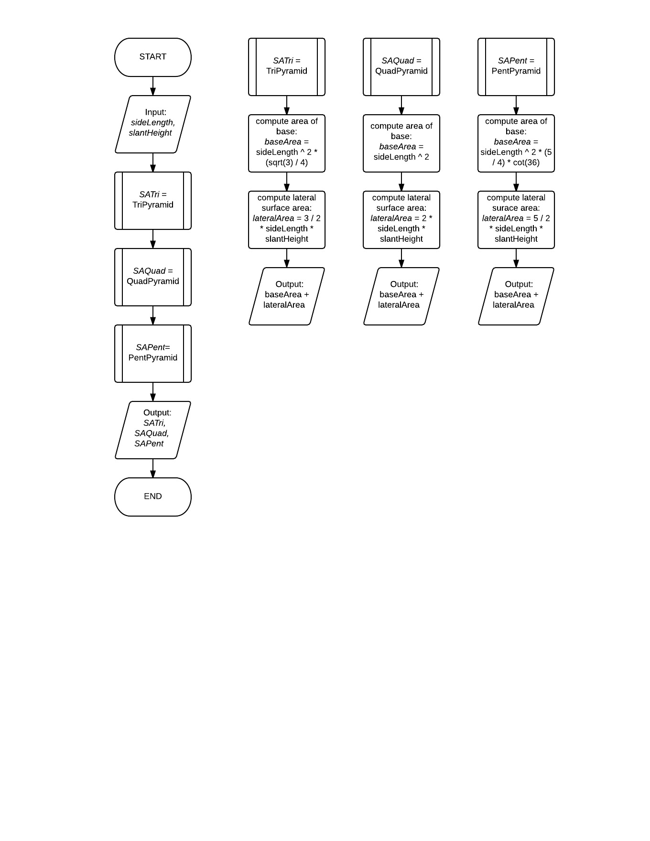

PART B:

Code: C2_ACT_Task1_katherto.c

PART C:

Code C2_ACT_Task1_katherto.py

1. The flow diagram created in part A could be used for both part B and part C.
2. No, there is not an analogous “library” of functions in MATLAB to ones created in C and Python.

**TASK 2**

PART A

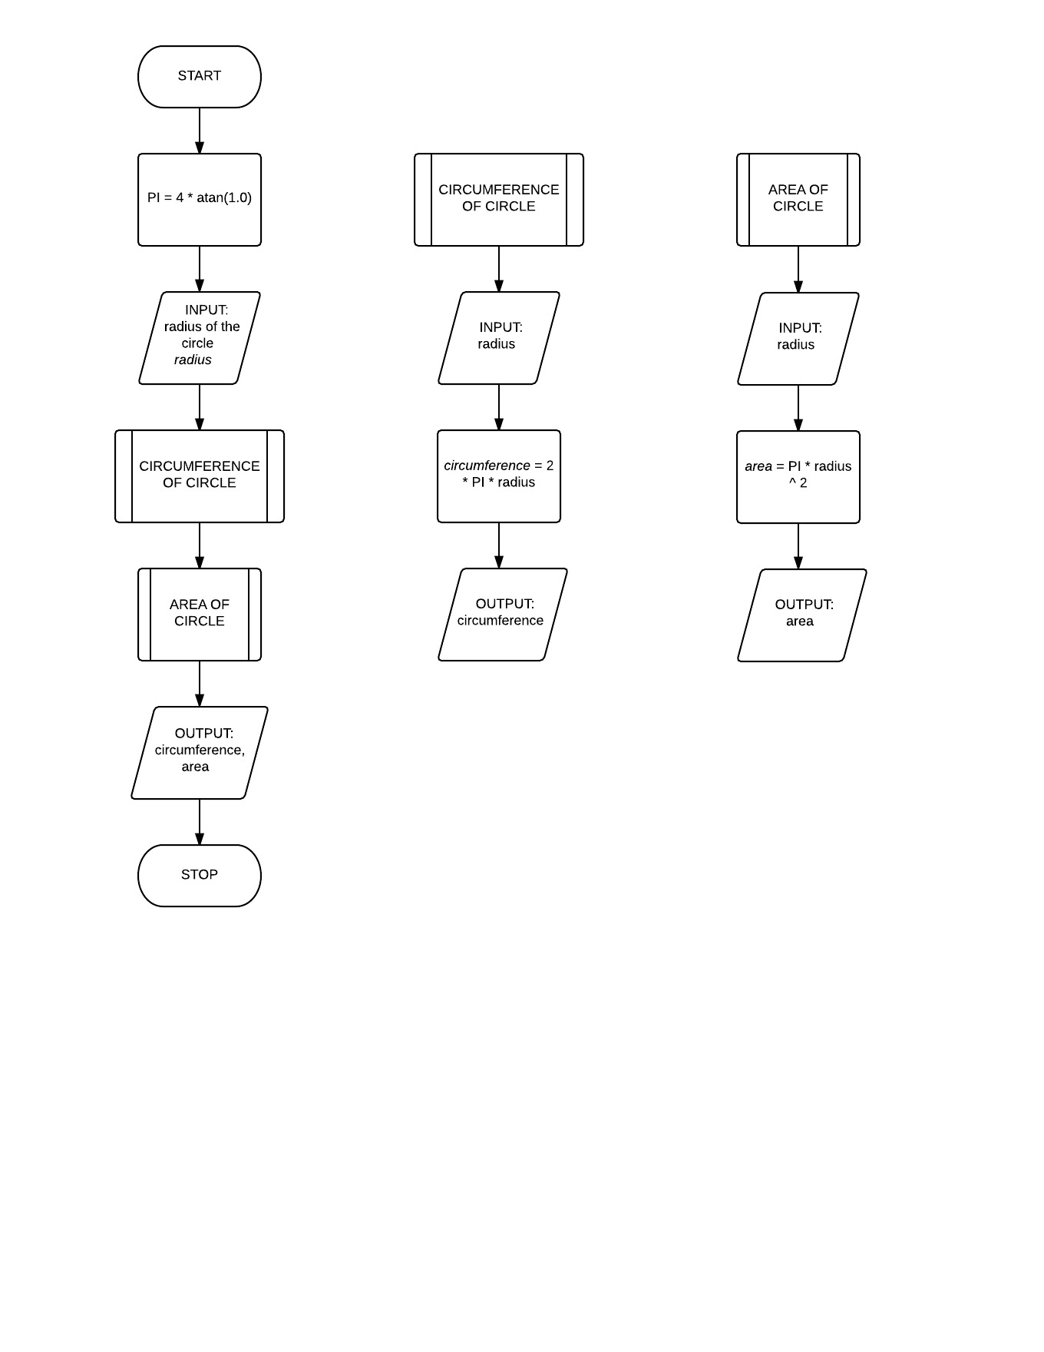

Code: file C2_ACT_Task2_katherto.c

PART B

Code: file C2_ACT_Task2_katherto.py

1. This order cannot be achieved in Python because the code runs sequentially and is not compiled, so the functions defined after they are called are seen as being “undefined.” This order cannot be achieved in MATLAB because the user-defined functions are their own files and are called by filename, not within the same script. However, if the functions are subfunctions of the main function, this order can be achieved, as this is the order in which functions and subfunctions are seen in MATLAB.
2. Functions are/are not different across the languages known.
3. When writing very large programs, using a library of functions and including the library using headers would be more appropriate, as the library would decrease the size of the program, as it takes the user-defined functions and puts them in a separate file, which the program then calls. It still works the same way, but the size of the main function is reduced in this manner.

**TASK 3**

PART A

Code: file C2_ACT_Task3_katherto.c

PART B

Code: file C2_ACT_Task3_katherto.c

PART C

Code: file C2_ACT_Task3_katherto.c

1. If you compile the file created above, it would work, but would not display anything, as there is not a print statement in the main function.
2. In ENGR 14200, you should not use functions without having a function prototype for that function.
3. A function prototype is similar to defining the variable in C, but for functions. It allows the programmer to define the function later. A function definition is the main body of the function where the commands of the function are specified. A function call is where the main function calls the user-defined function to perform its commands.

**TASK 4**

PART A

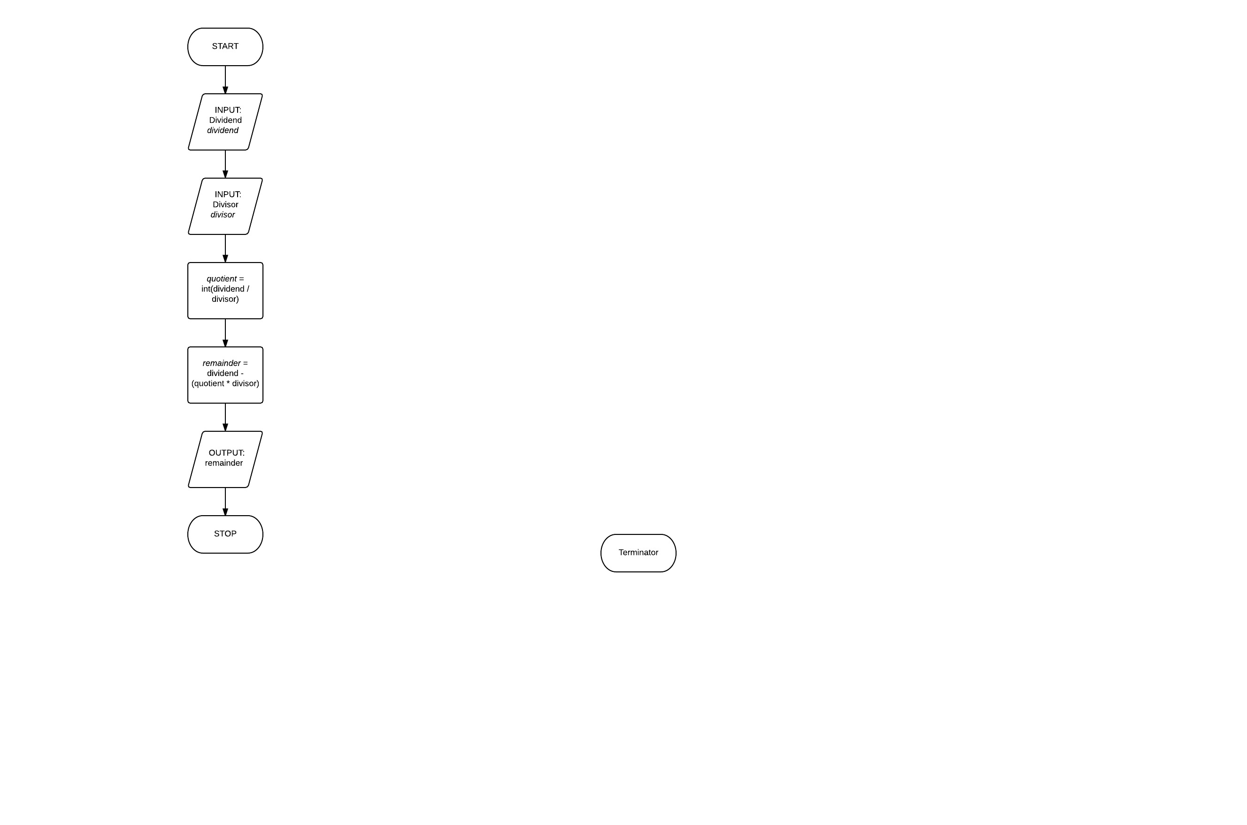

PART B

Code: file C2_ACT_Task4_katherto.c

PART C

Code: files C2_ACT_Task4_katherto.m, Modulo.m

1. The function Modulo() in MATLAB cannot be stored in a file saved with a different file name because MATLAB will not be able to call the function with the name Modulo, as it reads the function with the same name as the file name.
2. The algorithm did not look identical for C and MATLAB because integer division is available in C while it does not execute in MATLAB.
3. C allows for a better control of data types.

PART D

Code: file C2_ACT_Task4_katherto.c